**Assignment Group A (Unit I & II)**

|  |  |  |  |  |  |  |
| --- | --- | --- | --- | --- | --- | --- |
| **W (4)** | **C (4)** | **D (4)** | **V(4)** | **T (4)** | **Total** | **Sign** |
|  |  |  |  |  |  |  |

**Date of Performance ____________**

**Date of Completion** :_____________

**Problem Definition:**

**Setup a wired LAN using Layer 2 Switch. It includes preparation of cable, testing of cable using line tester, configuration machine using IP addresses, testing using PING utility and demonstrating the PING packets captured traces using Wireshark Packet Analyzer Tool.**

**1.1 Prerequisite:**

a) IP Address

b) OSI & TCP/IP Model

c) Networking Devices

**1.2 Learning Objectives**:

1. Understand how to Create LAN, PAN & CAN

2. Understand how to Create wireless LAN using Access Point.

**1.3 New Concepts:**

1. Crimping

2. Access Point Configuration

**1.4 Theory**

**1.4.1 Introduction**

A **computer network** is a system in which multiple computers are connected to each other to share information and resources.

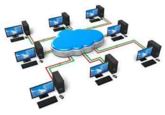

**Characteristics of a Computer Network**

****Share resources from one computer to another.

Create files and store them in one computer, access those files from the other computer(s) connected over the network.

Connect a printer, scanner, or a fax machine to one computer within the network and let other computers of the network use the machines available over the network.

**Network Cables**

Network cables are used to connect computers. The most commonly used cable is CAT cable & RJ-45.

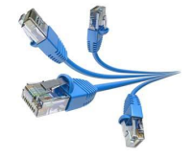

**Network Card**

Network card is a necessary component of a computer without which a computer cannot be connected over a network. It is also known as the network adapter or Network Interface Card (NIC). Most branded computers have network card pre-installed. Network cards are of two types: Internal and External Network Cards.

**Straight Through & Crossover Cable:**

The information listed here is to assist Network Administrators in the color coding of Ethernet cables. Please be aware that modifying Ethernet cables improperly may cause loss of network connectivity.

**Straight-Through Ethernet Cable**

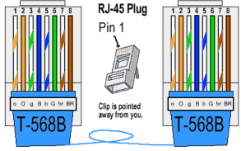

**Straight-Through Ethernet Cable**

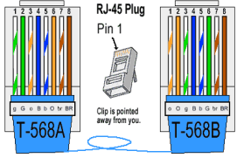

**Local Area Network:**

A local area network (LAN) is a computer network that interconnects computers within a limited area such as a residence, school, laboratory, university campus or office building and has its network equipment and interconnects locally managed. By contrast, a wide area network (WAN) not only covers a larger geographic distance, but also generally involves leased telecommunication circuits or Internet links. An even greater contrast is the Internet, which is a system of globally connected business and personal computers. Ethernet and Wi-Fi are the two most common transmission technologies in use for local area networks.

**Wireless LAN:**

A wireless local area network (WLAN) is a wireless computer network that links two or more devices using a wireless distribution method (often spread-spectrum orOFDM radio) within a limited area such as a home, school, computer laboratory, or office building. This gives users the ability to move around within a local coverage area and yet still be connected to the network. A WLAN can also provide a connection to the wider Internet.

Most modern WLANs are based on IEEE 802.11 standards and are marketed under the Wi Fi brand name.

**Benefits of Wireless LAN:**

****People can access the network from where they want; they are no longer limited by the length of the cable

Some places and vehicles have Wireless LANs. This means that people can access the internet even outside their normal work environment, for example when they ride a train.

Setting up a wireless LAN can be done with one box called wireless access point or wireless router. This box can handle many connections at the same time. Wired networks require cables to be laid. This can be difficult for certain places.

Access points can serve a varying number of computers.

**Using Packet tracer tool :**

Cisco Packet Tracer designed to be used as multi-tasking, that's been to examine varied network exercises like application of dissimilar topologies, development of apt servers, subnetting and study of different network setups, configuration and different troubleshooting defined commands. To initialise communication among two networking devices i.e., user networking devices and to organise a network, we intend to demand to pick applicable networking devices like routers hubs, switches or interconnecting devices and build physical change of integrity by connecting cables, quick local area network seaports from the module list of packet trace

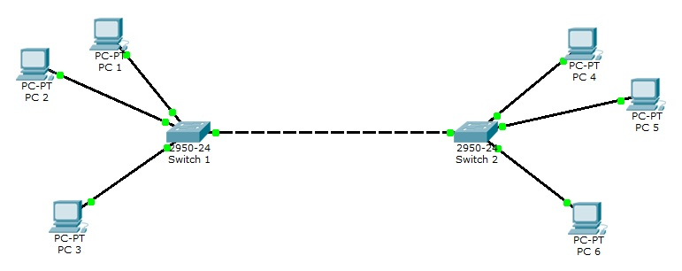

Steps:

Step 1: Launch Packet Tracer.

Step 2: Build the topology.

Step 3: Configure the Wireless Router.

Step 4: Configure the Laptop. Or

Step 5: Configure the PC.

Step 6 :Send the packets from one PC to another

**.5 Assignment Questions:**

1. Explain LAN, PAN, MAN & WAN?

2. Write down the Difference between TCP/IP Model & OSI Model? 3. Which Topology you have implemented in your laboratory? Why? 4. Explain various IEEE Standards for Wireless LAN?

5. How to Configure Wireless LAN Explain step by Step?

6. Which Security protocols are used in Wireless LAN?

7. Explain Ping, Traceroute, Telnet, Ipconfig Commands?

**Outcome:** Students could create packet tracer LAN protocol and understand the concept of Switches, routers etc